**Section 4: Enhanced model training based on state-of-the-art deep learning networks**

* **Tuned deep learning models, including Residual Network, Fully Connected Network, Inception, and EEGNet for better performance.**
* **Evaluated these models using confusion matrix**
* **Visualized and tracked the training process using Tensorboard**

**Conclusion: Achieved an increase of X% of recall, X% of precision, X% of accuracy, and X% of f1 score.**

**12/4/2021-12/5/2021:**

Researched about CNN. Key points: A deep learning algorithm. Use “convolutions” to extract features for you – take the input data and apply a filter on it, and the output would be a feature map – feature.

Researched about ResNet. Key points: Type of CNN. Solves the degradation and vanishing gradient problem through batch normalization, relu activation function, and the use of “skip connections” by passing information from the shallow layers to the deeper layers, so that at the very least, the performance would degrade, and can only be better.

**12/6/2021:**

Started implementing ResNet to see its performance on the preprocessed EEG data.

**12/20/2021:**

Implemented ResNet using the clean EEG data from the “yes” subjects that I have found that have great EEG data.

Initial results: precision: 55.18%, accuracy: 54.21%, recall: 54.21%, duration: 422 seconds

Talked to Khuong Vo on how to improve the algorithm

Conclusions

* Focus on the results analysis, because from the results, we can see how to improve it. See the performance in terms of different metrics.
* Make a case-by-case analysis of what samples for each subject the model predicted incorrectly and correctly, so that we can analyze the shortcomings of the model.
* Analyze the training process with Tensorboard to see how the weights of all the layers change after each epoch.

**12/21/2021:**

Made a case-by-case analysis of all the samples and put it into a dictionary. For each sample number, it contains the sample index, the predicted value, and the actual value. Talked to Khuong Vo. Should also analyze the patterns in both time and frequency domain of the failed cases. Used Tensorboard to visualize the training process. Visualized the histograms/distributions of all the layers so we can do an analysis of what is happening.

**12/22/2021:**

Visualized accuracy over time to see if there is any overfitting. Visualized the histograms/distributions of all the layers to see how the weights and biases change over time. Analyzed the failed cases both in time and frequency domains.

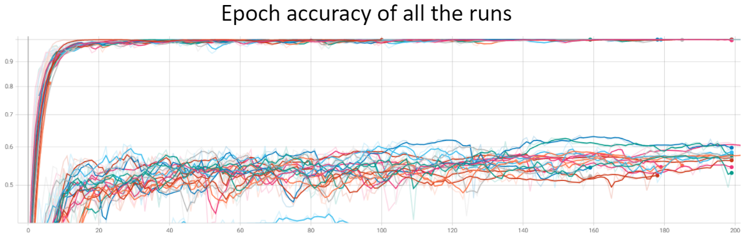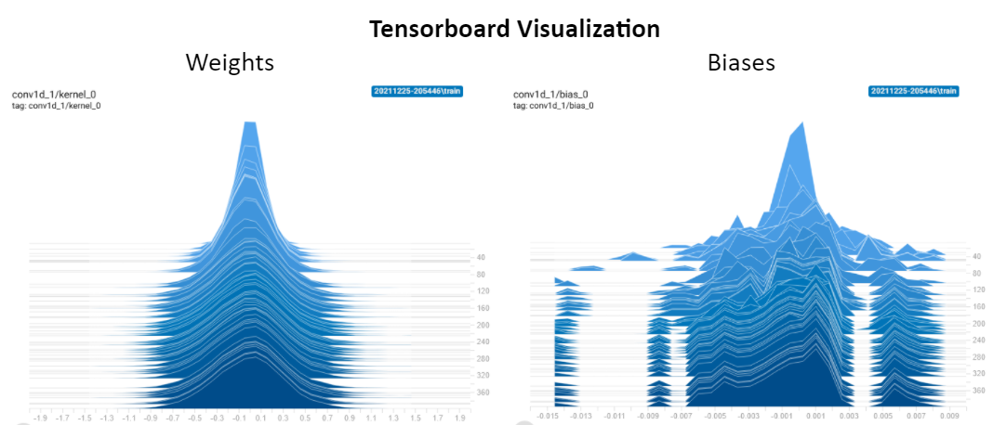

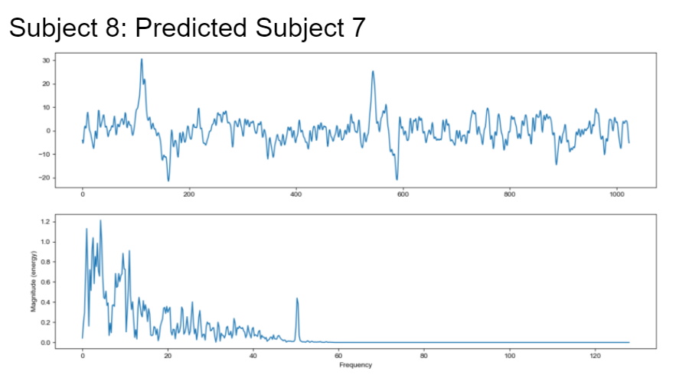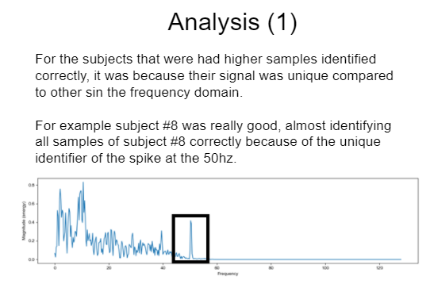

Read Learned about the Inception model, which is also a deep learning classifier. Key points: uses 1*1 convolutions for dimension reduction, smart factorizations (decomposing a 7*7 kernel into 2 3*3 kernels) for faster computations, and stacking of multiple paths (1*1, 3*3, 5*5, 7*7) to get the best results. Unlike ResNet which goes “deeper”, Inception goes “broader”.